NAME: K.Divya BATCH : 13

1. To change the permissions of a file using the **chmod** command, you need to specify the desired permissions to the file you want to modify. The syntax is as follows:

chmod permissions file

The "permissions" can be specified in various ways, including symbolic notation(ex: chmod u+rwx <filename> or numeric notation (ex: chmod 777 <filename>) For example, to give execute permissions to user of a file named "myfile.txt," you would run:

chmod u+x myfile.txt

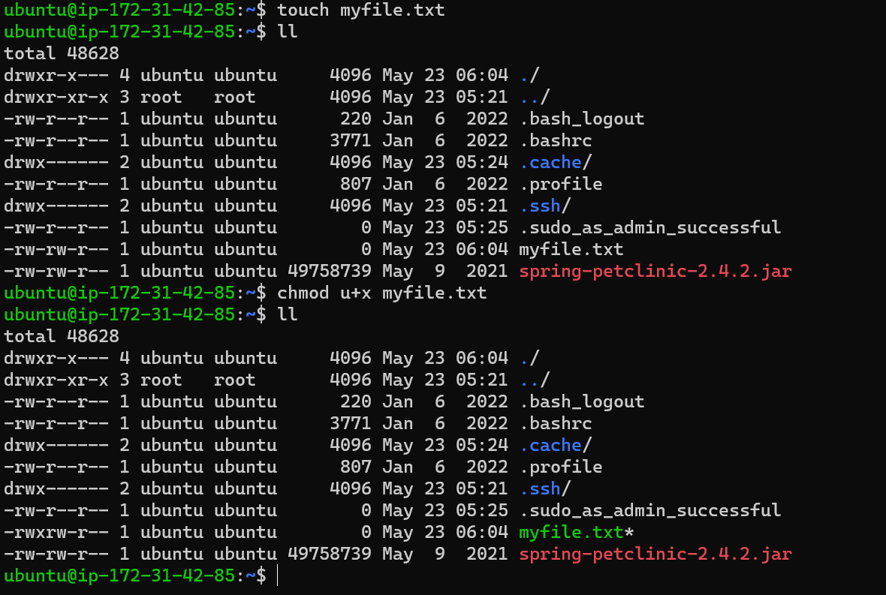

2.  To create a file named "myfile.txt" in the current directory using a command

**Touch myfile.txt**

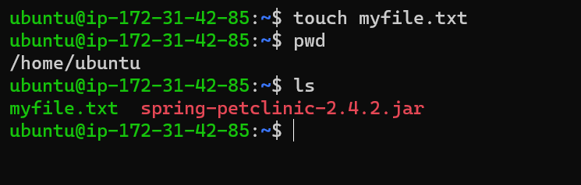

3.  The command to show listening ports using netstat is

**netstat -l**

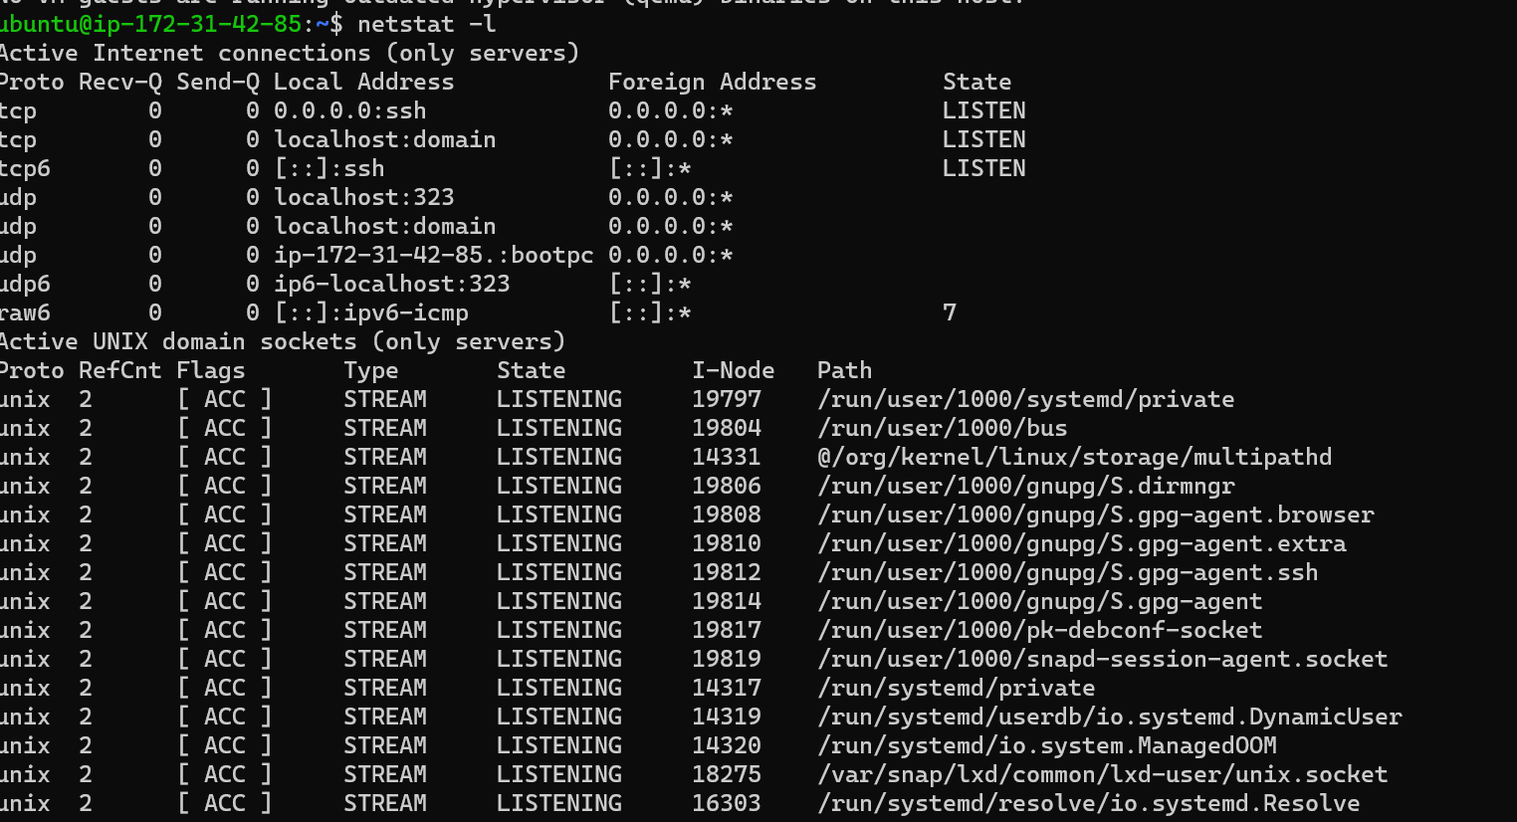

4. To exit a telnet session gracefully the command we use is ctrl+]

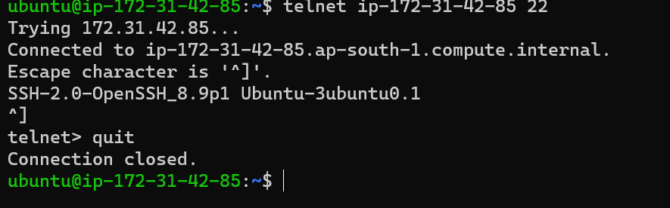

5. To display the disk space usage in human-readable format with du the command is

**du -h**

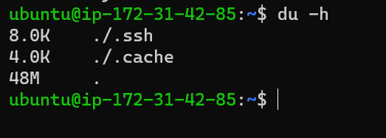

For specific file the command is **du -h myfile.txt**

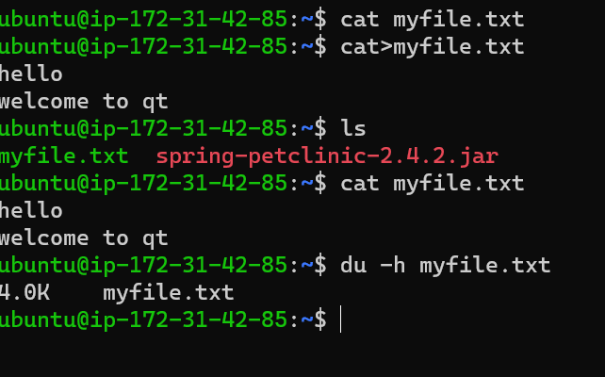

6. To recursively change the owner and group of a directory and its contents using chown and chgrp the command is

**Chown -R < new owner> <directory>**

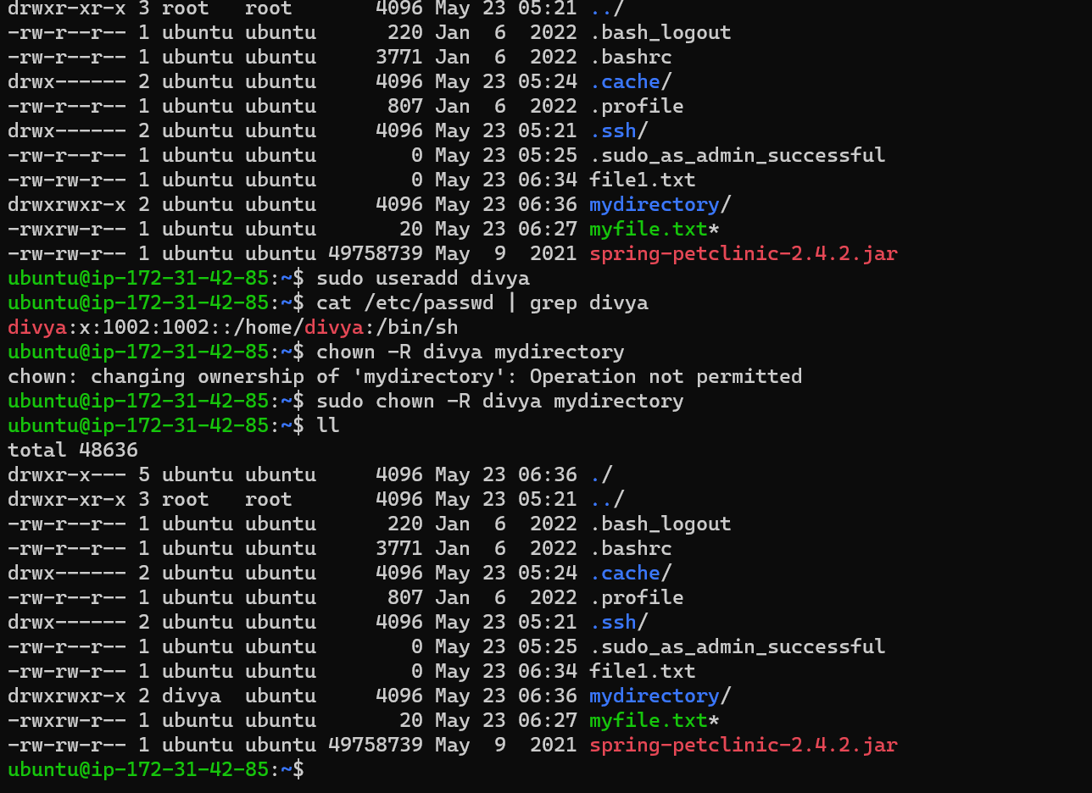

**Chgrp -R <new group> <directory>**

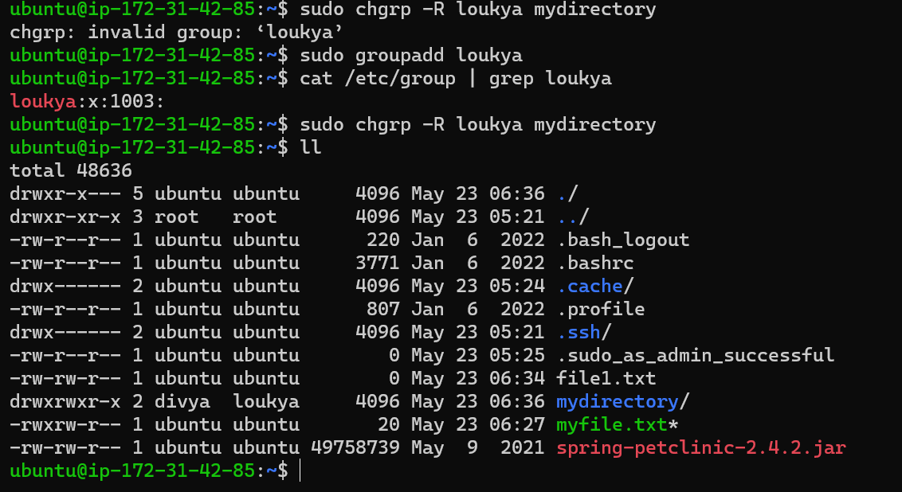

7.The command to redirect the output of echo to a file is

**Echo <message or variable> > <file>**

